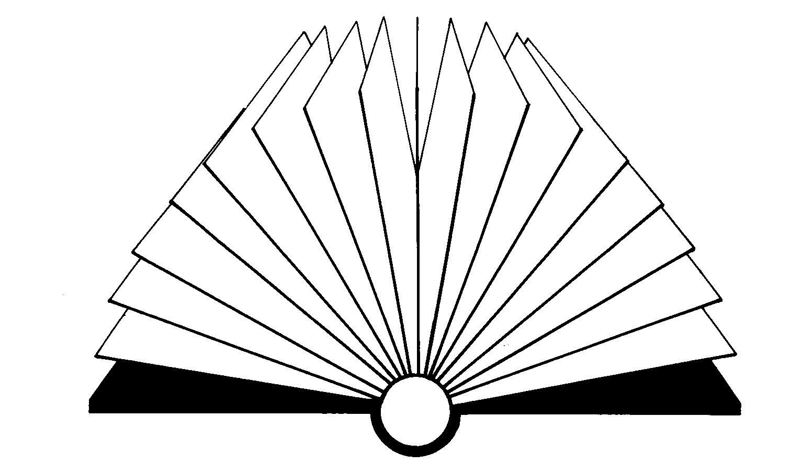
Celebrate NWT Literacy Week

Word Bingo

Synonym Version
(ages 12 and up)

When: ______________

Where: ______________
Time: ______________
Cost: FREE!!!!

Lots of fun and great prizes!

Sponsored by ____________________

