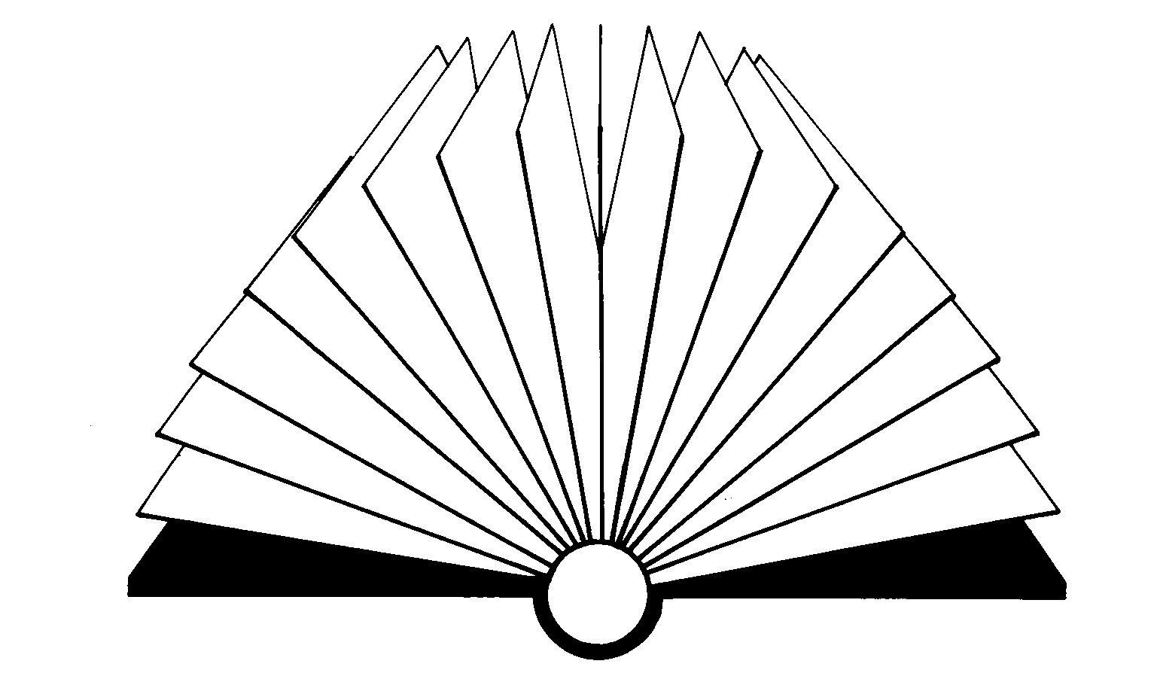Word Bingo
Distribute | Think over | Great joy | Not obvious | Many
Avoid | Clothes | Name | Withdraw | Cheerful
Free | Rude | NWT Literacy Council | Tell | Right
Easy | Bright | Stir up | Having to do with cooking | Awful
Bravery | Destroy | Calm | Hate | Mean

Garbage | Real | About to happen | Dislike | False report
Maze | Strong | Alone | Big | Ask
Collect | Withdraw | NWT Literacy Council | Colour | Famous
Wander | Avoid | Name | Handy | Middle
Annoy | Manners | Open to influence | Wander | Shine

Word Bingo
Can be saved | Strong | Complaint | Manners | Garbage
Awful | Congratulate | Make worse | Boring | Not enough
Bravery | Rude | NWT Literacy Council | Chop | Follow
Collect | Avoid | Hate | Shine | Scold
Shine | Braid | Handy | Middle | Right

Drunk | Get better | About to happen | Middle | Confused
Destroy | Empty | Scold | Not believable | Nearsightedness
Calm | Distribute | NWT Literacy Council | Tease | Braid
Steady | Strong | Ready to argue | Buy | Famous
Name | Ask | Begin | Think over | Having a big appetite

Word Bingo
Rude | Make worse | Bright | Many | Deep sleep
Think over | Alone | Famous | Bend | Clothes
Scold | Having a big appetite | NWT Literacy Council | Hate | Shine
Brain | Big | Collect | Manners | Stir up
Joke | Pure | Ask | Choose | Fair

City | Big | Praise | Having opposite feelings | Ruin
Withdraw | Secret | Famous | Destroy | Easy
Pure | Complaint | NWT Literacy Council | Middle | Great joy
Nearsightedness | Maze | Wander | Make worse | Bold
Joke | Choice | Think over | City | Steady

Word Bingo
Ruin | Not enough | Ready to argue | City | Bold
Steady | Famous | Joke | Fair | Awful
Garbage | Handy | NWT Literacy Council | Great joy | Think over
Bright | Choice | Confused | Praise | Wander
Follow | Secret | Stubborn | Having opposite feelings | Cheerful

Make worse | Boring | Congratulate | Stir up | Ready to argue
Bravery | Ruin | Braid | Collect | Dislike
Having to do with cooking | Annoy | NWT Literacy Council | Now | Buy
Size | Empty | Can be saved | Big | Tell
Rude | Calm | Handy | Not believable | City

Word Bingo
Annoy | Destroy | Not believable | Tell | Shine
Braid | Make worse | Boring | About to happen | Open to influence
Free | Buy | NWT Literacy Council | Right | Confused
Pure | Ask | Calm | Chop | Strong
Manners | Brain | City | Hate | Stir up

Free | Easy | Praise | Fair | Dislike
Shine | Bright | Choice | Distribute | Tell
Handy | Collect | NWT Literacy Council | Think over | Middle
Bravery | Having a big appetite | Clothes | Alone | Braid
Garbage | Chop | Ruin | City | Calm

Word Bingo
Dislike | Stubborn | Bend | Name | Braid
Follow | Handy | Calm | Collect | Awful
Not believable | Having opposite feelings | NWT Literacy Council | Rude | Praise
Choose | Shine | Ready to argue | Right | Scold
Think over | False report | Easy | Buy | Difference

Make  worse | Boring | Steady | Ask | Fair
Empty | About to happen | Take away | Great joy | Dislike
Follow | Congratulate | NWT Literacy Council | Many | Deep sleep
Maze | Follow | Chop | Clothes | Mean
Confused | Ruin | Avoid | Middle | Rude

Word Bingo
Strong | Buy | Destroy | Awful | Manners
Nearsightedness | Braid | Brain | Make worse | Boring
Size | Fair | NWT Literacy Council | Stubborn | Avoid
Take away | Alone | Chop | Boring | Tell
Big | Rude | Manners | Withdraw | Importance

Scold | Right | Choice | Difference | Annoy
Praise | Chop | Steady | Many | Garbage
Take away | Great joy | NWT Literacy Council | Ruin | About to happen
Tell | Chop | Tease | Empty | Think over
Bright | Awful | False report | Ruin | Ready to argue

Word Bingo
Confused | Annoy | Choose | Braid | Steady
Deep sleep | Awful | Can be saved | Now | Not sure
Real | Importance | NWT Literacy Council | Withdraw | Having a big appetite
Annoy | Empty | Hate | Read to argue | Bend
Famous | Get better | Begin | Free | Brain

Congratulate | Collect | Wander | Praise | Stubborn
Not sure | Fair | Empty | Open to influence | Ruin
Having a big appetite | Size | NWT Literacy Council | Famous | False report
Deep sleep | Tell | Manners | Bold | About to happen
Stir up | Scold | Think over | Complaint | Strong

Word Bingo
Great joy | Withdraw | False report | Right | Scold
Annoy | Awful | Manners | Big | Make worse
Steady | Joke | NWT Literacy Council | Choose | Bend
Collect | Ruin | Shine | Ready to argue | Bravery
Can be saved | Nearsightedness | Famous | Distribute | Now

Having to do with cooking | Drunk | Size | Not sure | Bravery
Tell | Congratulate | Boring | Ask | Open to influence
Empty | Fair | NWT Literacy Council | Secret | Complaint
Real | Right | Annoy | Rude | Not believable
Chop | Make worse | Steady | Manners | Big

Word Bingo
Mean | Stubborn | Tease | Deep sleep | Right
Stir up | Ruin | Shine | Calm | Bold
Congratulate | Annoy | NWT Literacy Council | Having to do with cooking | Clothes
Destroy | Choice | Buy | Now | Open to influence
Praise | Make worse | Think over | Middle | Real

Importance | False report | Buy | Difference | Colour
Big | Deep sleep | Braid | Follow | Bend
Name | Open to influence | NWT Literacy Council | Empty | Praise
Hate | Bravery | Complaint | Great joy | Not sure
Distribute | Begin | Free | Joke | Pure

Word Bingo
Nearsightedness | Maze | Annoy | Ask | Real
Importance | Scold | Difference | Easy | Alone
Get better | False report | NWT Literacy Council | Having to do with cooking | Chop
Rude | Wander | Cheerful | Big | Tell
Hate | Size | Empty | Now | Stir up

Stir up | Not sure | Maze | Make worse | Chop
Confused | Praise | Tease | Bend | Great joy
Ruin | Ready to argue | NWT Literacy Council | Think over | Get better
Free | Easy | Difference | Now | Rude
Many | Garbage | City | Bright | Alone

Word Bingo
Handy | Congratulate | Big | Manners | Confused
Joke | Distribute | Easy | Buy | Not enough
Bravery | Real | NWT Literacy Council | Can be saved | Nearsightedness
Maze | Colour | Dislike | Choose | Fair
Ruin | Avoid | Complaint | Secret | Importance

About to happen | Not sure | Mean | Stubborn | Praise
Not obvious | Big | Not believable | Follow | Make worse
Garbage | Annoy | NWT Literacy Council | Ask | Empty
Tease | Not sure | Collect | Great joy | Shine
Avoid | Having opposite feelings | Chop | Boring | Name

Word Bingo
Garbage | Big | Maze | Clothes | Think over
Not enough | Strong | Right | Begin | Choice
Get better | Having to do with cooking | NWT Literacy Council | Take away | Now
Difference | Cheerful | Bold | Steady | Tell
Manners | Deep sleep | Many | Annoy | Bend

Free | Distribute | Alone | Tell | Bright
Braid | Bold | Steady | Tease | Tell
Joke | Pure | NWT Literacy Council | Fair | Collect
Hate | Avoid | Shine | Clothes | Importance
Having a big appetite | Right | False report | Destroy | Drunk

